**Instructions to students for Online Examination (June-July, 2021)**

**University Institute of Engineering and Technology, Panjab University**

**(For Students)**

**TASKS TO BE DONE- BEFORE THE EXAMINATION:**

1. **Download Datesheet**

DATESHEETS: Datesheets are available at the examination link i.e., https://exams.puchd.ac.in/datesheet.php

1.1 **NOTICE BOARD**: All students are advised to keep accessing the notice board at the link given below regularly for important announcements as all updates are posted here only & will not be sent to the candidates by any other means. https://exams.puchd.ac.in/show-noticeboard.php

2. **Create gmail-id**

All students must create their separate gmail-id to submit their answer sheets. The format of email Id is

First NameFull RollNoBranch Name@gmail.com

Branch Name:ECE

Example: Aditi [UE168001ece@gmail.com](mailto:UE168001ece@gmail.com)

**TASKS TO BE DONE- ON THE DAY OF THE EXAMINATION:**

1. **DOWNLOADING THE QUESTION PAPER**

* Question papers will be available at PU website **online.puexam.in**. The students can download the question papers directly from the Download Question Paper link without logging-in. **All students appearing in these examinations will download the question papers on their own from the website**

**The students must ensure that they have downloaded the correct question paper.**

* The question papers will be available for the different time-slots in the following manner:

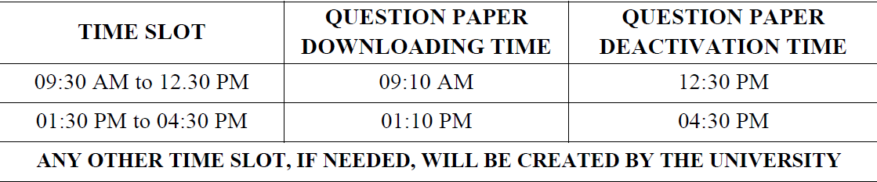

1. **MARKING THE ATTENDANCE in 2 modes compulsory (whats app and Google form)**

Mandatory to submit attendance up to 9:45 am for morning session

Mandatory to submit attendance up to 1:45 pm for evening session

* Students have to mark the attendance in respective whats app group with the following message

Attendance_Roll No_ FullName_Mode Of submission (Physical/Online)

Eg: Attendance_UE 168001_AditiKapoor_online

* Students also have to mark the attendance in google form link which will be shared each day before the commencement of exam.

1. **ATTEMPTING THE QUESTION PAPER:**

a) The instructions given in the question paper should be followed. **No separate instructions will be given.**

b) Duration of paper is to be considered as written on the question paper.

c) Number of questions to be attempted should strictly be according to the instructions given in the question paper itself.

d) The candidates must attempt the paper with blue ball-point pen.

1. **A4 SIZE SHEETS FOR WRITING THE ANSWERS:**
2. Under-Graduate students can use 20 A4 Size sheets and Post-Graduate students can use 24 A4 Size Sheets. **Only one side of the sheet should be used for writing the answers.**
3. The candidates are advised to write their answers precisely and attempt the question paper not exceeding the page limit [refer point 3(a)]
4. Representative Soft Copy of the total Answer sheets of 20 A4 Pages for UG courses and 24 A4 Pages for PG Courses will be uploaded on the portal i.e. online.puexam.in. The candidates may either download and print the required answer sheet or write on any other A4 size plain or ruled sheets as per their choice. **However, a mandatory condition is that the particulars regarding the candidate details to be written on the first page of the answer sheet are in accordance with representative soft copy uploaded by the University. Roll number should be mentioned only on first page at designated place and nowhere else in whole of answer book.** If roll number is mentioned at any other place, the answer book may be not be processed for evaluation and may stand rejected.

**Some more points to remember:**

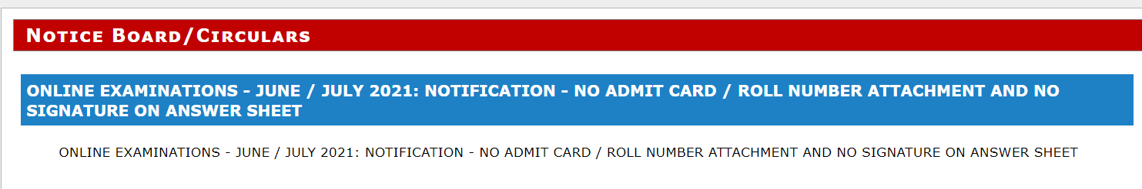

1. **New notification available on https://exams.puchd.ac.in/, clearly indicates no admit card/roll no. attachment and no candidate signature on any page including first page of answer sheet is allowed.**
2. **Below-mentioned box details are not required to write anywhere on the answer-sheet** 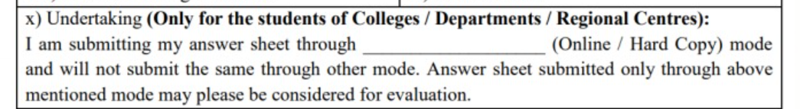
3. **SUBMISSION OF THE ANSWER SHEETS BY STUDENTS**

The students of Colleges / University Departments / Regional Centre may submit the answer sheet either online or physical mode of submission (prior notification is required).

**Submission of answer sheet through both ways is not permitted.**

The candidates should opt only one manner of submission of answer sheet. If the student has opted online mode for submission of the answer sheet, it should be done within 60 minutes of the completion of the paper in both morning and evening slots.

Students are required to make a single pdf of their answer sheet and Email the same to their own Email ID also. This is to be done mandatorily on the day of examination and within stipulated time of 60 minutes after completion of exam.

**NOTE:**

1. **Students should submit their answer sheets of respective examinations through google form link. The google form link will be shared on whatsapp group at 11:00 am for morning session and at 3:30 pm for evening session. Only One time submission is allowed. So, before the submission verify the details.**
2. **Kindly make sure to use the registered email id while submitting the answer-sheet.**
3. **If you fail to submit answer sheet in respective time slot, the google form link will be deactivated.** In this casestudents can submit their answer sheets of respective examinations on their branch specific email-id as given below:

[ece.uietpu@puchd.ac.in](mailto:ece.uietpu@puchd.ac.in)

1. Answer-sheets received on branch specific email-id after the allocated time will be forwarded to Director UIET and Examination Coordinator for further action. **Only after getting the recommendation from authorities answers sheets will be considered for the evaluation.**

**Submission of hard copy of the answer sheet for papers conducted in morning slot should be done through the physical mode of submission by 02:00 PM and for evening slot by 06:00 PM** on the same day of examination, subject to the maximum time limit as allowed by the respective institute.

1. **Scanning, creating and uploading a single pdf**

A demo video for scanning, creating and uploading a single pdf of whole of answer sheet to the portal is available for the students on the portal i.e. online.puexam.in. The page number should be written on each page and the pages must be scanned in a serial order. Uploading the answer sheet in a JPEG format is not permissible. Only Pdf format is acceptable. After creating pdf, you are advised to open it and verify that pdf is created properly.

1. All important announcements / information / notices related to examinations are always uploaded to the notice board / datesheet section in examination link of Panjab University website and **ONLY THESE ARE TO BE CONSIDERED AUTHENTIC.**
2. In case any student confronts any problem in downloading the question paper, he / she may call the helpline numbers provided on the portal i.e. **online.puexam.in**

NOTE: Visually Impaired or Disabled Students are allowed to have assistance from a scribe / writer as per the University Rules and no separate permission from the University is required for this purpose.